- The Monetary Policy Committee voted to cut Bank Rate by 25bps to 4.75% at its meeting this week. Most MPC members concluded that although last week's Budget was likely to boost growth and inflation, a gradual approach to loosening policy remained appropriate.
- Market expectations for Bank Rate have risen sharply since the MPC's forecast was locked. But with the MPC forecasting 2% inflation in the medium-term, its implicit message is that rates will fall faster than markets expect. We have maintained our forecast that the MPC will cut Bank Rate by 100bps in 2025.
The Bank of England's Monetary Policy Committee sent a clear message at the August and September meetings that it would pursue a gradual approach to loosening policy. Following a 25bps cut to Bank Rate in August and a hold in September, we viewed another 25bps cut at this week's meeting as a near-certainty. Therefore, our focus was on whether there were any hints that a majority of MPC members might depart from the 'cut-hold' tempo that's becoming established and back a faster pace of rate cuts.
The MPC voted 8-1 to lower Bank Rate by 25bps to 4.75%. Catherine Mann was the sole dissenter, as she continues to lean towards the most hawkish of the MPC's three scenarios of varying inflation persistence. The other eight members, including Huw Pill and Megan Greene who had voted against a rate cut in August, coalesced in support of the MPC's middle scenario, which assumes a period of slack is required for price- and wage-setting dynamics to fully normalise. This underpinned their view that a gradual approach to loosening policy was appropriate and that a 25bps cut was in line with this message.
For the first time, the MPC explicitly tied its central forecast to the middle scenario. This forecast showed CPI inflation falling back to the 2% target in the medium-term, based on market interest rate expectations that Bank Rate would fall by around 100bps to 3.75% by the end of 2025 (Chart 1). Compared with August, the new inflation forecast was lower in the near-term as it took on board recent data that had been softer than expected. But the new projection is higher from mid-2025 onwards, largely due to the measures announced in last week's Budget, which the BoE estimates will raise GDP by 0.75ppts next year.
Chart 1: Stronger demand from the Budget led the BoE to raise its inflation forecast
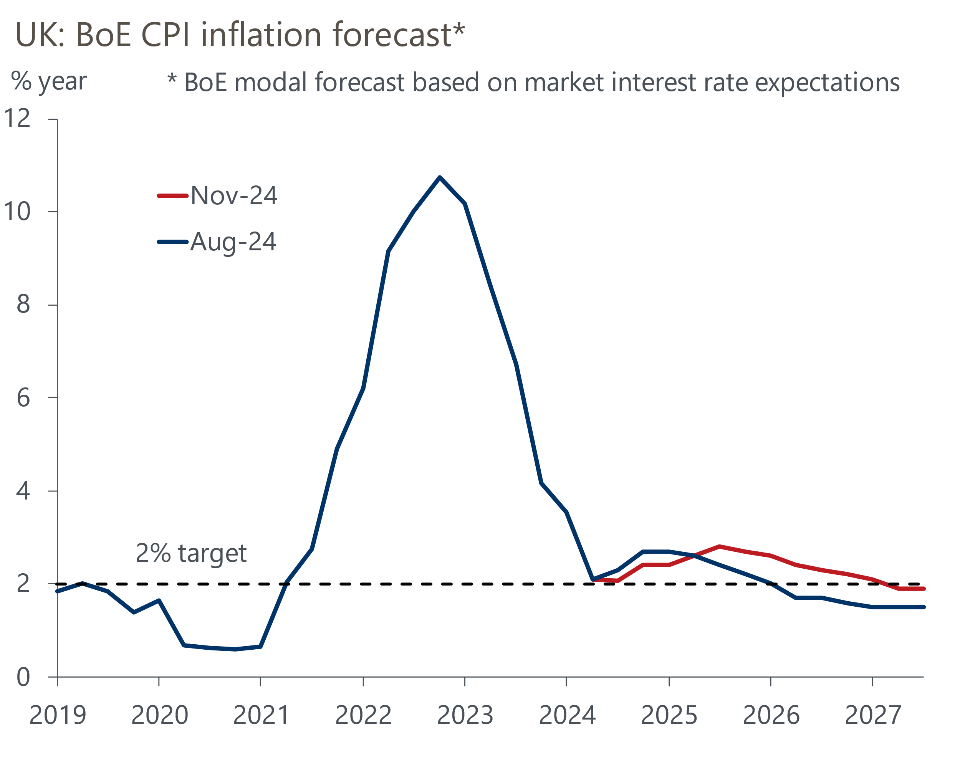
Source: Bank of England Monetary Policy Report

That the new inflation forecast returns to the 2% target in the medium-term, despite the Budget implying less spare capacity will open up, suggests that the majority of the committee is confident that the growth/inflation trade-off has improved. The MPC's confidence that inflation persistence is abating will have been bolstered by the survey of the BoE's regional agents, which reported that firms expected early-2025 pay settlements to be in the 2%-4% range. While this is a relatively wide range, it is a pace of pay growth that's broadly consistent with the MPC meeting the inflation target on a sustained basis.
The elephant in the room was that the MPC's forecasts were conditioned on a snapshot of the market-implied path for interest rates over the 15 days to October 29. Markets have repriced significantly since then, due to the Budget and the US election. At market close on Wednesday, expectations for Bank Rate at the end of 2025 were nearly 50bps higher than the level used in the Monetary Policy Report (Chart 2).
Chart 2: Market pricing has moved significantly since the BoE locked its assumptions
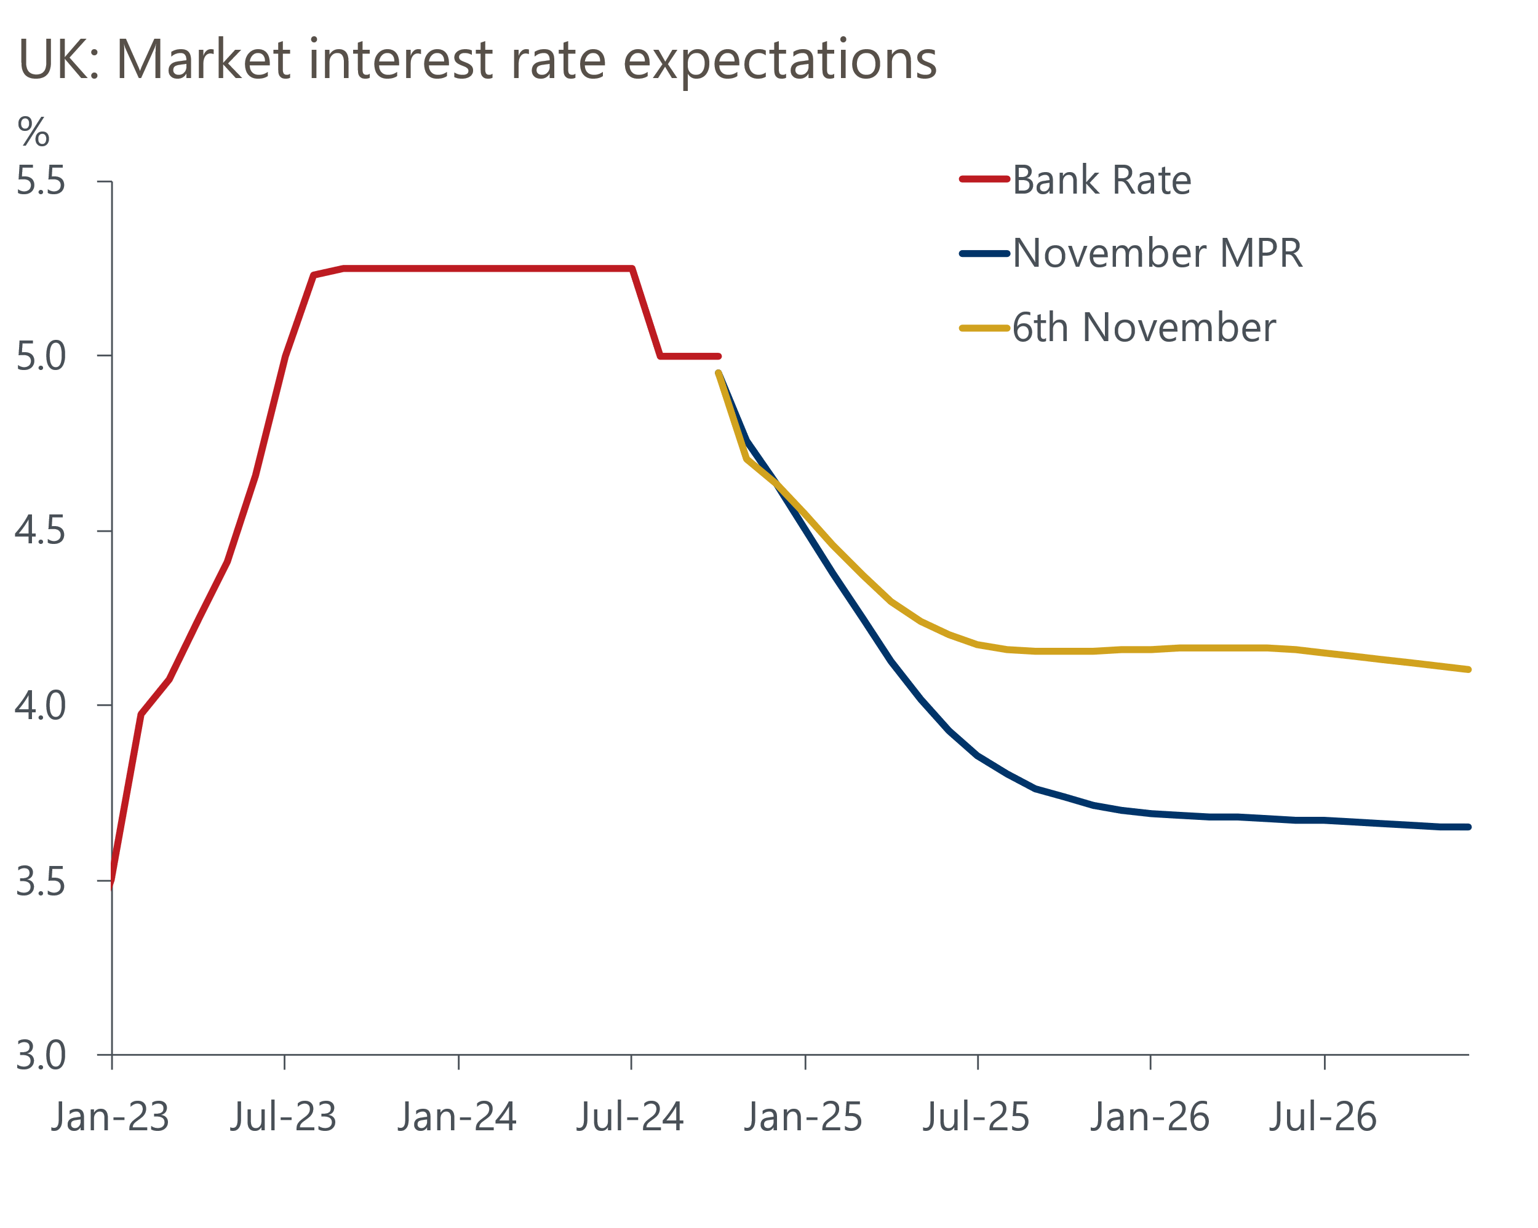
Source: Haver Analytics
Given the BoE's inflation forecast incorporates the impact of the less restrictive fiscal policy stance implied by the Budget, and sees inflation falling back to the 2% target in the medium term, the clear implication is that the MPC expects to cut rates more quickly than current market pricing implies. Indeed, it suggests that the MPC is broadly comfortable with the 100bps of cuts by the end of 2025 embodied in its conditioning assumptions.
With the BoE's forecast now explicitly tied to the MPC's middle scenario and the minutes not offering any benchmarks against which the committee might judge that the scenario probabilities are changing, there was nothing to suggest the MPC will increase the tempo of rate cuts in the near-term.
The MPC meeting came too late to be reflected in our new forecast, which includes the impacts of policy changes announced in last week's Budget and the implications of adopting our 'limited Trump' scenario. But we will stick with our previous forecast that the MPC will cut rates by 100bps next year, which would take Bank Rate to 3.75% by end-2025.
We've kept our 2025 GDP growth forecast for the UK unchanged at 1.5%, and we've nudged up our 2026 forecast by 0.1ppt to 1.7%. But the relative stability in the headline growth rates masks key changes in the detail. We now expect UK growth will rely more heavily on government consumption, with the outlooks for consumer spending and business investment slightly weaker than before.
But the impacts of Trump's return on the outlook are highly uncertain at this point. For now, we’ve adopted our 'limited' scenario, which assumes the UK is not part of the new US tariff regime. But we will keep this assumption under close scrutiny. We're also mulling whether a more volatile global backdrop might cause inflation expectations to rise again. If this scenario begins to play out, then we would expect to see Bank Rate remain higher over the medium-term.

The week ahead
The first of the week's two major economic releases is the labour market data for July-September. Whole economy total pay growth continued to ease in the three months to August, helped by strong base effects. Base effects from large private sector bonuses paid out in September 2023 mean we expect headline total pay growth to have softened again to 3.8% in September. Meanwhile, there's a good chance that the cooling momentum in underlying pay conditions continued in September, so we think regular pay growth fell modestly to 4.6%.
On the quantities side, Labour Force Survey data remains plagued by volatility, with the Office for National Statistics yet to implement planned methodological improvements. With June's implausibly low single-month reading dropping out of the three-month average, we expect the unemployment rate ticked up to 4.2% in the three months to September.
The week will also see the release of GDP data for September. Activity rose in August, but there were a lot of erratic movements at the sectoral level – most notably in the distribution, transport, and art & recreation sectors – which weighed on output growth. We expect these drags to have unwound in September, while the major sectors are likely to show signs of modest growth. As a result, we estimate that GDP grew by 0.2% m/m in September.
Table 1: Week ahead calendar
Date | Events | Period | Measure | Unit | Previous | Forecast
Nov 12 | LFS unemployment | Jul-Sep | Rate | % | 4.0 | 4.2
Nov 12 | Average earnings (total pay) | Sep | 3m, y/y | % | 3.9 | 3.8
Nov 12 | Average earnings (regular pay) | Sep | 3m, y/y | % | 4.8 | 4.6
Nov 15 | GDP | Sep | m/m | % | 0.2 | 0.2
Nov 15 | GDP | Sep | 3m/3m | % | 0.2 | 0.2
Nov 15 | Index of services | Sep | m/m | % | 0.1 | 0.3
Nov 15 | Index of services | Sep | 3m/3m | % | 0.1 | 0.2
Nov 15 | Manufacturing output | Sep | m/m | % | 1.1 | 0.1
Nov 15 | Manufacturing output | Sep | y/y | % | -0.3 | 0.3
Nov 15 | Industrial production | Sep | m/m | % | 0.5 | 0.6
Nov 15 | Industrial production | Sep | y/y | % | -1.6 | -0.6
Nov 15 | Construction output | Sep | m/m | % | 0.5 | 0.0
Nov 15 | Construction output | Sep | y/y | % | 0.3 | -0.7
Nov 15 | UK trade | Sep | Trade balance | £bn | -1.0 | 0.6
Nov 15 | UK trade | Sep | Visible balance | £bn | -15.1 | -13.5
Source: Oxford Economics

Key forecasts
Table 2: UK forecast overview
(Annual percentage changes unless specified)
 | 2022 | 2023 | 2024 | 2025 | 2026 | 2027
GDP | 4.8 | 0.3 | 1.0 | 1.5 | 1.7 | 1.8
Private consumption | 7.3 | 0.5 | 0.8 | 1.7 | 1.5 | 1.6
Fixed investment | 5.1 | -0.1 | 0.6 | 1.2 | 3.4 | 2.5
Government consumption | 0.6 | 0.6 | 2.4 | 2.9 | 1.6 | 1.6
Exports of goods and services | 12.6 | -2.2 | -0.8 | 3.0 | 2.0 | 1.8
Imports of goods and services | 13.0 | -3.4 | 2.8 | 3.2 | 2.6 | 1.8
Industrial Production | -6.4 | -1.2 | -0.8 | 1.0 | 1.2 | 1.0
Consumer prices | 9.1 | 7.3 | 2.5 | 2.5 | 2.5 | 2.2
Unemployment rate (%) | 3.9 | 4.0 | 4.3 | 4.4 | 4.3 | 4.2
Current a/c balance (% of GDP) | -2.2 | -2.0 | -2.9 | -2.7 | -2.9 | -2.8
Government balance (% of GDP) | 4.1 | 4.9 | 4.4 | 3.5 | 2.8 | 2.2
Cen. bank policy rate (%, EOP) | 3.50 | 5.25 | 4.75 | 3.75 | 2.75 | 2.00
10yr govt. bond yield (%, EOP) | 3.67 | 3.54 | 4.50 | 4.05 | 3.34 | 2.85
Exchange rate (US$ per £, EOP) | 1.20 | 1.27 | 1.27 | 1.29 | 1.30 | 1.33
Exchange rate (euro per £, EOP) | 1.13 | 1.15 | 1.21 | 1.20 | 1.19 | 1.19
Source: Oxford Economics
Table 3: Quarterly forecasts for the UK
 | 2024 |  |  |  | 2025
 | Q1 | Q2 | Q3 | Q4 | Q1 | Q2 | Q3 | Q4
GDP (% year) | 0.3 | 0.7 | 1.1 | 1.9 | 1.6 | 1.5 | 1.6 | 1.5
CPI inflation (% year) | 3.5 | 2.1 | 2.1 | 2.4 | 2.5 | 2.3 | 2.7 | 2.6
Bank Rate (%, EOP) | 5.25 | 5.25 | 5.00 | 4.75 | 4.50 | 4.25 | 4.00 | 3.75
10yr gilt yield (%, EOP) | 3.95 | 4.17 | 4.00 | 4.50 | 4.42 | 4.31 | 4.19 | 4.05
US$ per £ (EOP) | 1.26 | 1.26 | 1.34 | 1.27 | 1.27 | 1.28 | 1.28 | 1.29
Euro per £ (EOP) | 1.17 | 1.18 | 1.20 | 1.21 | 1.21 | 1.21 | 1.21 | 1.20
Source: Oxford Economics

Latest Country Economic Forecast:
October 15, 2024

Recent publications

Data Insights
Composite PMI consistent with trend growth in late-2024
Manufacturing PMI slipped below 50 in October
Cheaper deals supported a further rise in mortgage approvals
October PMI gives further signal growth has softened in H2
September public finances point to another borrowing overshoot

Research Briefings
MPC sticks to the cut-hold tempo
Markets have soured on the Budget, but calm should return
MPC preview – November cut looks virtually certain
New fiscal rules create room for looser policy
Can PSNW be used for a fiscal rule?

Contacts

Oxford Economics' UK team
- Andrew Goodwin - Chief UK Economist - agoodwin@oxfordeconomics.com
- Edward Allenby - UK Economist - eallenby@oxfordeconomics.com

